**Aim:** To Construct a use case diagram for a Hospital Management System using StarUML.







**Sample:** We use the Sample of a Buyer-Seller model diagram constructed in StarUML to describe the diagram construction procedure.

**Step 1:** 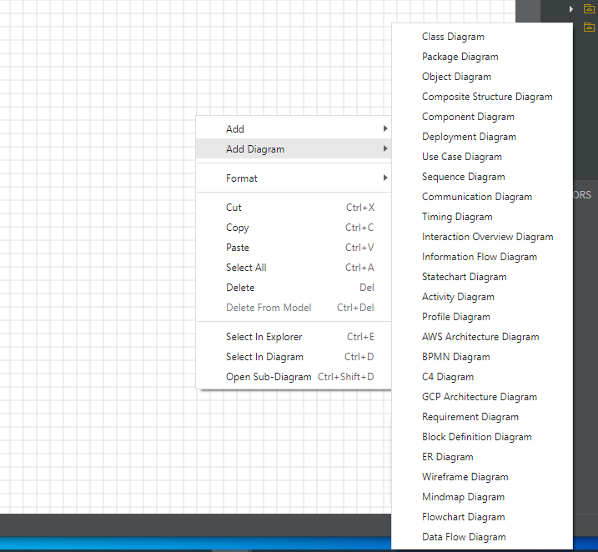

**Step 2:**

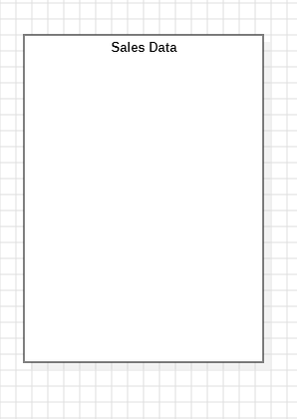

SSSS

**Step 3:**

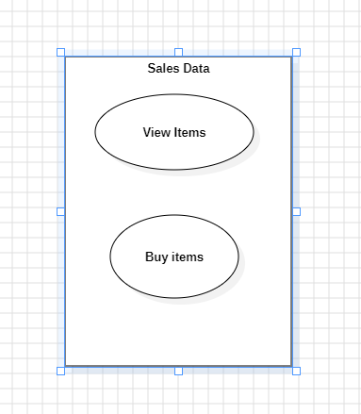

**Step 4:** 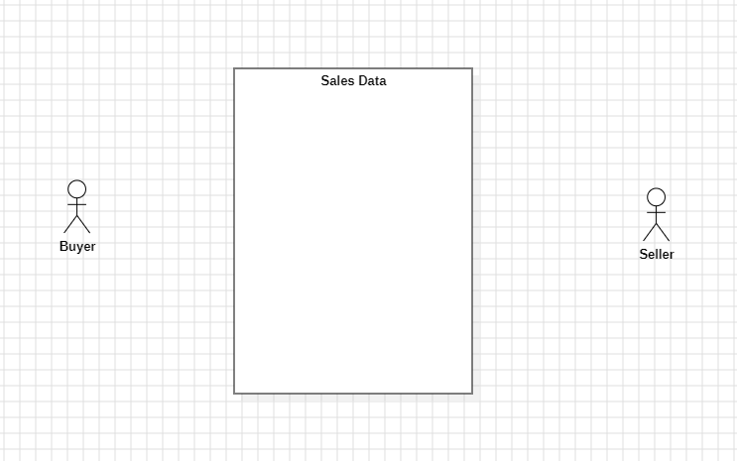

**Step 5:**

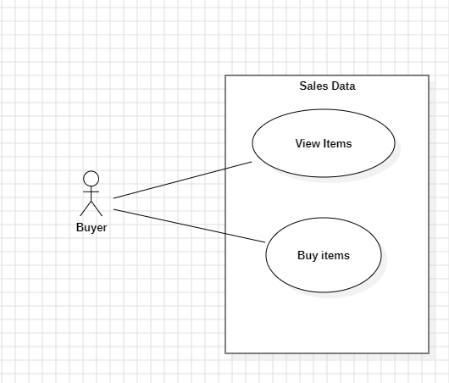

**Step 6:** 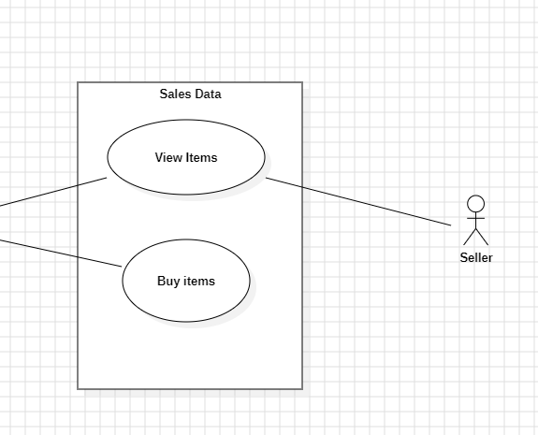

**Completed Diagram:**

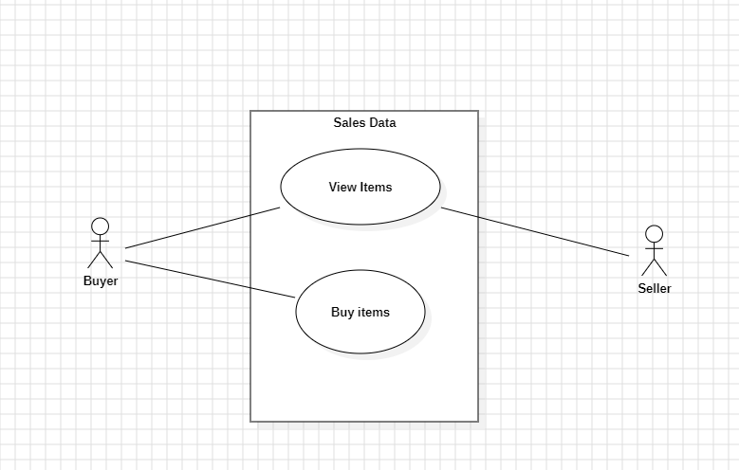

**Hospital Management System Diagram:**

The hospital management system is a more detailed diagram, constructed in the same manner as the buyer-seller diagram mentioned above.

